PROJECT REPORT
Implement Client Script & UI Policy (Incident)
Project ID / Team ID: SWTID-2026-6670
Platform: ServiceNow | Table: Incident
Skills: Incident Management, UI Policy, UI Policy Actions, Client Scripts, Form Validation

1. INTRODUCTION

1.1 Project Overview
Incident records need consistent and accurate data to support triage, routing and resolution. This project uses ServiceNow client-side controls to enforce data integrity on the Incident form. A UI Policy named High Impact Control makes Assignment group mandatory and Urgency read-only when Impact is High, and reverses these effects when the condition no longer applies. Three Client Scripts add further behaviour: an onChange script auto-sets Urgency, an onSubmit script blocks saving a High-impact incident without Assigned To, and an onCellEdit script prevents State changes from list view.

1.2 Purpose
The purpose is to demonstrate how UI Policies and Client Scripts dynamically control field visibility, mandatory status and read-only behaviour, auto-populate values and validate data at save time, so that Incidents are created with complete and valid information. This improves reporting accuracy, SLA compliance and overall service quality.

2. IDEATION PHASE

2.1 Problem Statement
Relying solely on user awareness and manual checks leads to incomplete, inconsistent or incorrect Incident data. This affects reporting accuracy, SLA compliance and service quality. There is a need to enforce conditional field behaviour and validation directly at the user-interface level, so that Incident records meet defined business rules before they are submitted.

2.2 Empathy Map Canvas
Quadrant | Service desk agent / ITSM administrator
Says | "Why do some high-impact incidents arrive with no assignment group?"  "I need clean data to route and report correctly."
Thinks | Incomplete records delay triage and risk SLA breaches.  Rules should be enforced by the form, not by memory.
Does | Creates and updates incidents, sets Impact and Urgency, assigns tickets, edits State from lists.
Feels | Frustrated by rework and inconsistent data; confident when the form guides entry.
Pains | Missing Assignment group / Assigned To on critical incidents.  Urgency not matching Impact.  Accidental State changes from list view.
Gains | Complete, consistent incidents.  Faster routing and fewer SLA breaches.  Trustworthy reports.

2.3 Brainstorming
The team compared several ways to enforce the rules and selected those that give immediate, form-level control.
# | Idea | Pros / Cons | Decision
1 | Server-side Business Rule to validate on save | Strong enforcement, but errors appear only after save; no live field feedback | Future scope
2 | UI Policy for conditional mandatory / read-only fields | Declarative, no code, reversible with Reverse if false | Selected
3 | onChange Client Script to auto-set Urgency | Instant feedback, small script | Selected
4 | onSubmit Client Script to block incomplete saves | Prevents bad data before it reaches the server | Selected
5 | onCellEdit Client Script to lock State in lists | Closes the list-edit bypass | Selected
6 | Data Policy for all entry channels | Covers imports and APIs, needs more testing | Future scope

3. REQUIREMENT ANALYSIS

3.1 Customer Journey Map
Stage | Create incident | Set impact | Assign | Submit | Review in list
User action | Opens Incident > Create New | Selects Impact | Fills Assignment group / Assigned To | Clicks Submit | Opens Incident > All
System response | Blank form | High: Urgency auto-set, Assignment group mandatory | Fields enforced | Blocks save if Assigned To is empty (High) | Blocks State edit with alert
Emotion | Neutral | Guided | Clear | Corrected early | Protected
Opportunity | Pre-fill defaults | Explain rule in messages | Suggest groups | Clear error text | Show locked-field hint

3.2 Solution Requirement
Functional requirements
ID | Requirement | Implemented by
FR-1 | Make Assignment group mandatory when Impact is High | UI Policy action (Mandatory = True)
FR-2 | Make Urgency read-only when Impact is High | UI Policy action (Read only = True)
FR-3 | Revert policy effects when Impact is no longer High | UI Policy Reverse if false
FR-4 | Auto-set Urgency to High when Impact is set to High | onChange Client Script
FR-5 | Block save when Impact is High and Assigned To is empty | onSubmit Client Script
FR-6 | Block State changes made through list editing | onCellEdit Client Script
Non-functional requirements
Non-functional | Description
Usability | Immediate on-form messages and clear error text beside the field
Security / Integrity | Only Admin/configuration roles can change policies and scripts; invalid records are stopped before submit
Reliability | Rules apply consistently on every Incident form load and change
Performance | Rules run client-side in the browser; no extra server round trip for field behaviour
Maintainability | Declarative UI Policy plus three short scripts; easy to review and deactivate
Scalability | Table-level rules apply to all Incident records without extra configuration

3.3 Data Flow Diagram
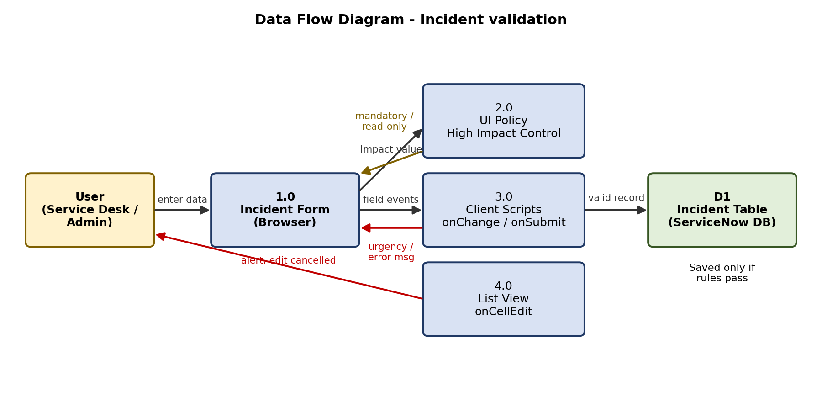
Figure 1: Data flow of Incident validation

3.4 Technology Stack
Layer | Technology
Platform | ServiceNow (Now Platform) developer instance
Configuration | System UI > UI Policies, UI Policy Actions, Client Scripts
Scripting | Client-side JavaScript using g_form (setValue, getValue, showFieldMsg, showErrorBox) and list callbacks
Data | Incident table [incident]
Access | Web browser; System Administrator account

4. PROJECT DESIGN

4.1 Problem Solution Fit
Problem | Solution fit
Incomplete data on high-impact incidents | UI Policy forces Assignment group; onSubmit forces Assigned To
Urgency inconsistent with Impact | onChange sets Urgency to High; UI Policy locks it
Data changed without context in lists | onCellEdit blocks State edits and directs users to the form
Rules becoming permanent after Impact change | Reverse if false restores normal behaviour

4.2 Proposed Solution
Create a table-level UI Policy on Incident with the condition Impact is 1 - High and Reverse if false enabled. Its actions make Assignment group mandatory and Urgency read-only. Add an onChange Client Script on Impact to set Urgency to 1 - High, an onSubmit Client Script to stop saving when Impact is High and Assigned To is empty, and an onCellEdit Client Script on State to cancel list edits and alert the user.

4.3 Solution Architecture
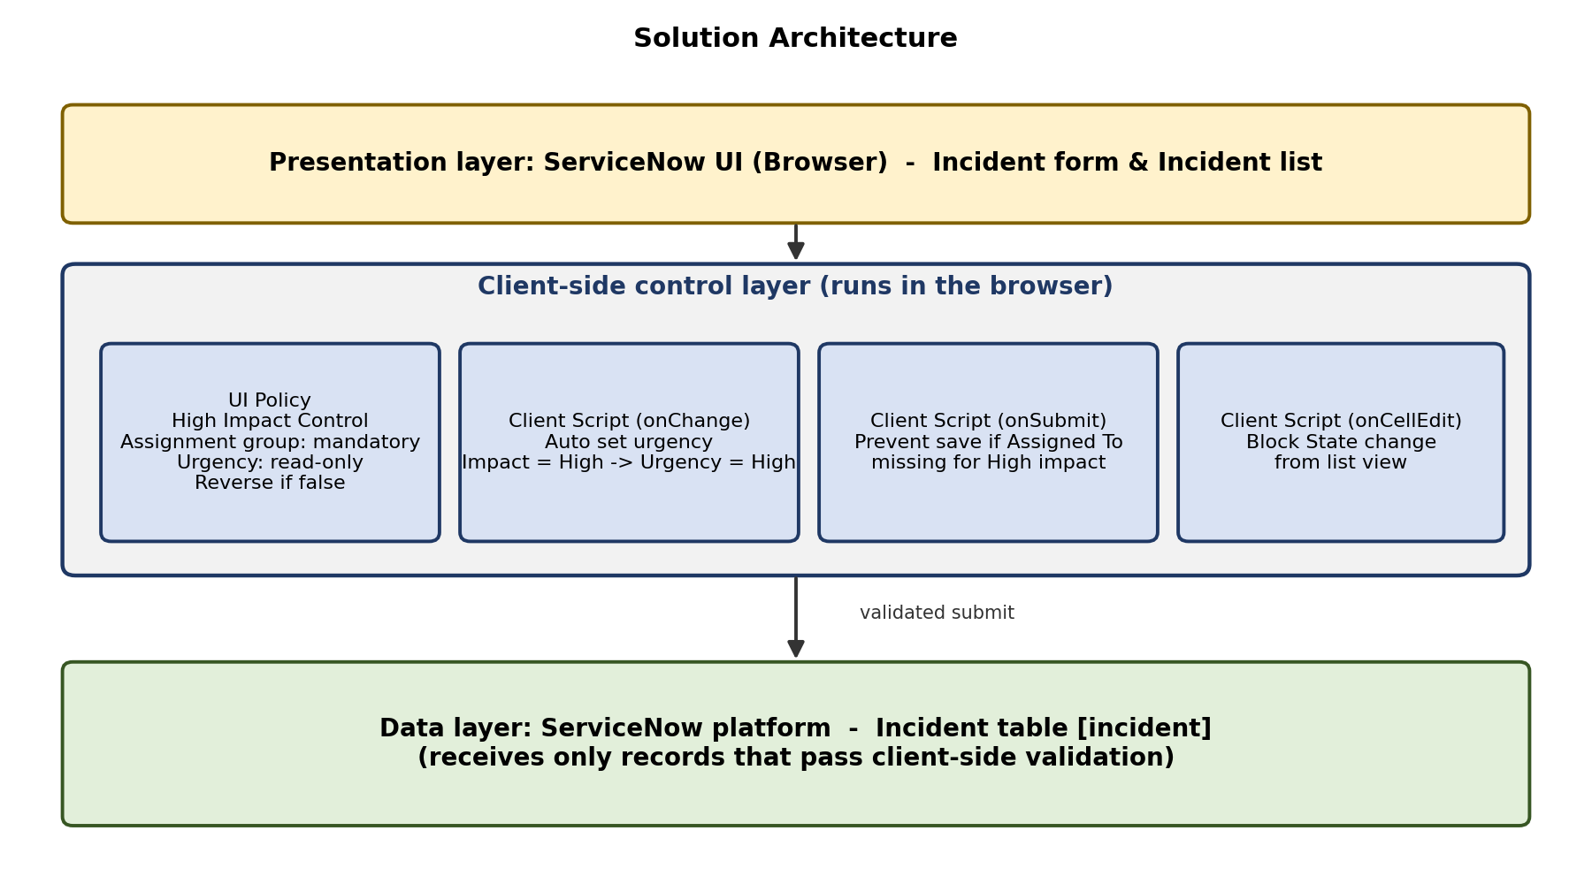
Figure 2: Solution architecture

5. PROJECT PLANNING & SCHEDULING

5.1 Project Planning
The work was planned as 12 user stories in 2 sprints of 6 days each, estimated on the scale 1, 2, 3, 5.
Sprint | Epic | USN | User story / task | Pts | Priority | Status
1 | UI Policy Configuration | USN-1 | Create High Impact Control UI Policy | 3 | High | Done
1 |  | USN-2 | Assignment group mandatory action | 2 | High | Done
1 |  | USN-3 | Urgency read-only action | 2 | High | Done
1 | Client Script Development | USN-4 | onChange: auto set Urgency | 3 | High | Done
1 |  | USN-5 | onSubmit: prevent save | 3 | High | Done
1 |  | USN-6 | onCellEdit: block list State edit | 2 | Med | Done
2 | Testing & Validation | USN-7 | Test mandatory enforcement | 3 | High | Done
2 |  | USN-8 | Test successful save | 2 | High | Done
2 |  | USN-9 | Test reverse condition | 2 | High | Done
2 |  | USN-10 | Test list-edit blocking | 2 | Med | Done
2 |  | USN-11 | Test form-based update | 1 | Med | Done
2 | Project Documentation | USN-12 | Prepare project documentation | 3 | Med | Done
Sprint tracker
Sprint | Total points | Duration | Start date | End date (planned) | Points completed
Sprint-1 | 15 | 6 Days | 05 Jan 2026 | 10 Jan 2026 | 15
Sprint-2 | 13 | 6 Days | 12 Jan 2026 | 17 Jan 2026 | 13
Total | 28 | 12 Days | 05 Jan 2026 | 17 Jan 2026 | 28
Velocity = total story points completed / number of sprints = 28 / 2 = 14 story points per sprint. Average velocity = 14 / 6 days = 2.33 story points per day.
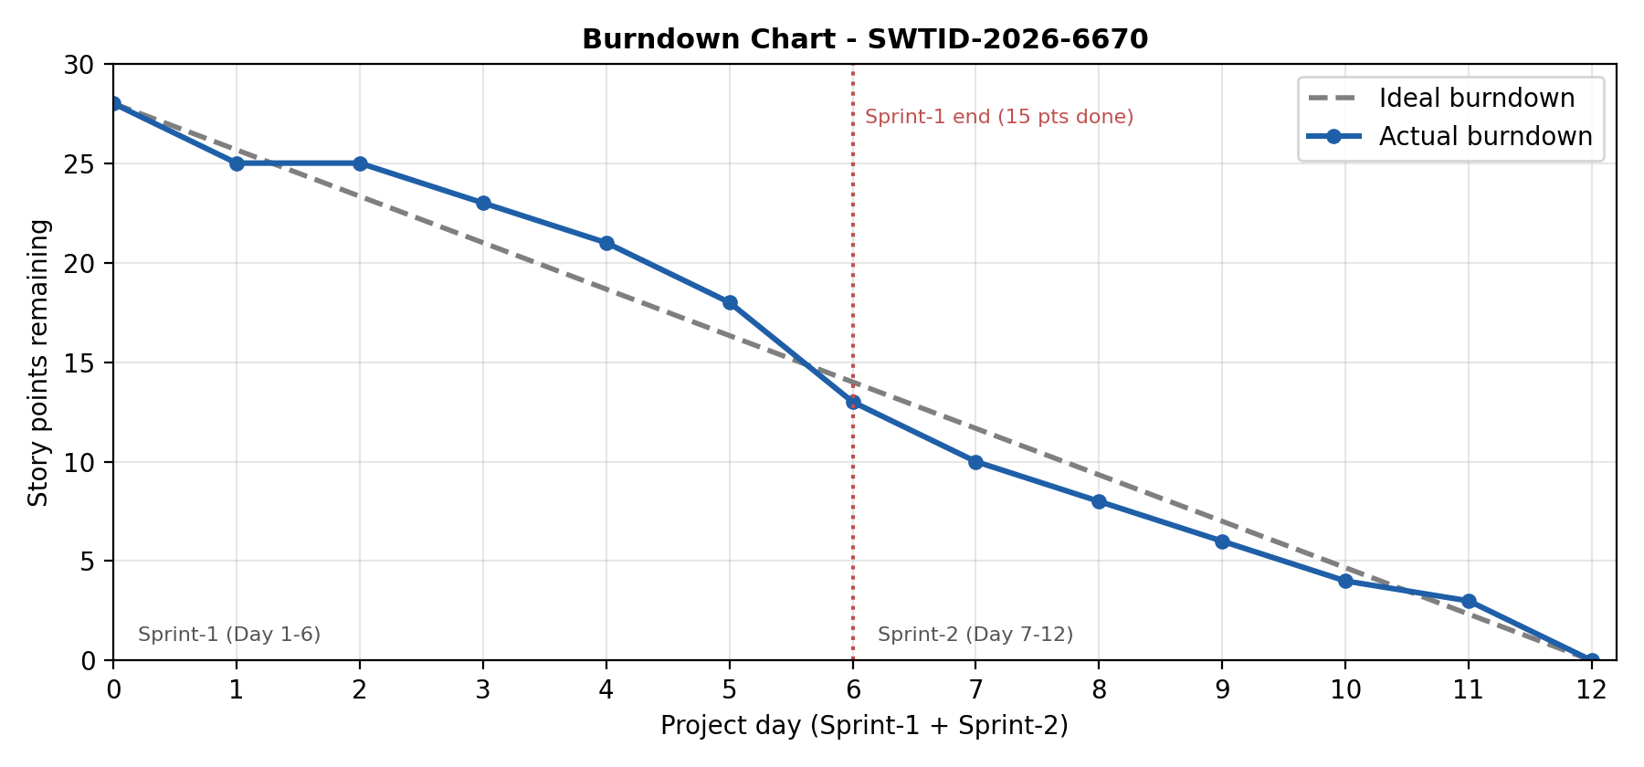
Figure 3: Burndown chart (28 story points over 12 days)

6. FUNCTIONAL AND PERFORMANCE TESTING

6.1 Performance Testing
Functional test results: all 9 test cases passed, with no failed or untested cases (details in the UAT report).
ID | Scenario | Expected result | Result
TC-001 | Impact = High: Assignment group | Becomes mandatory | Pass
TC-002 | Impact = High: Urgency | Read-only | Pass
TC-003 | High to Medium (Reverse if false) | Mandatory removed; Urgency editable | Pass
TC-004 | onChange: set Impact High | Urgency set to 1 - High with message | Pass
TC-005 | onSubmit: High, Assigned To empty | Save blocked with error | Pass
TC-006 | onSubmit: Assigned To filled | Incident saved | Pass
TC-007 | onSubmit: Impact Medium | Incident saved | Pass
TC-008 | onCellEdit: edit State in list | Alert shown; value unchanged | Pass
TC-009 | State edit on form | Change saved | Pass
Performance observations: all rules are client-side and respond on field change or submit without a page reload. During testing the Urgency update, mandatory and read-only changes, error message and list alert appeared immediately. No quantitative timing or load tests were run, so no response-time figures are reported.

7. RESULTS

7.1 Output Screenshots
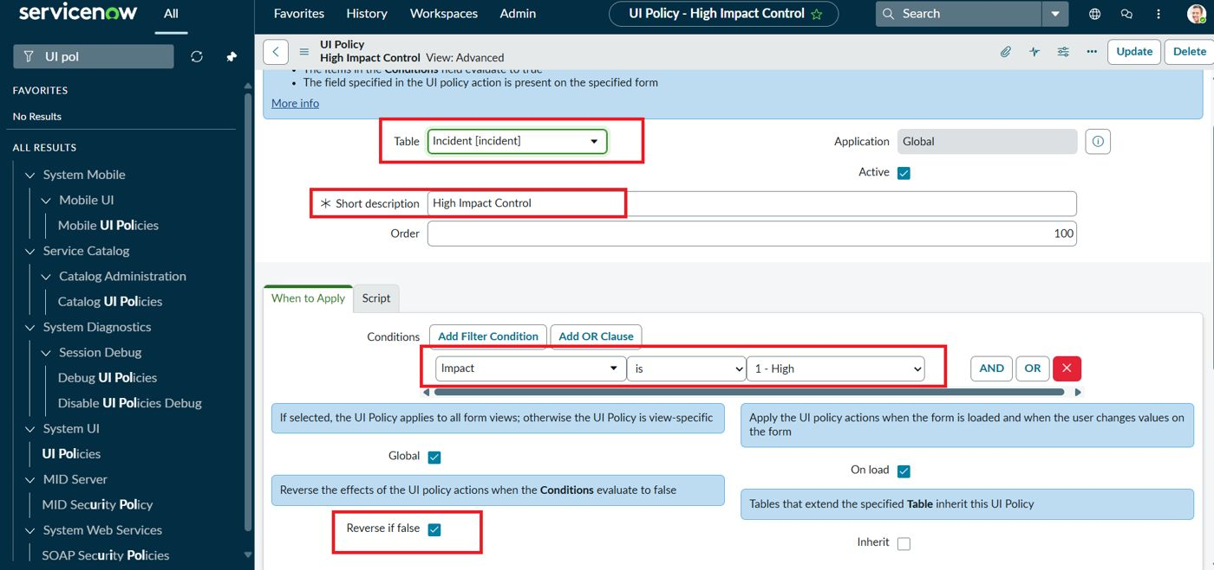
Figure 4: High Impact Control UI Policy (Incident table, Impact is 1 - High, Reverse if false)
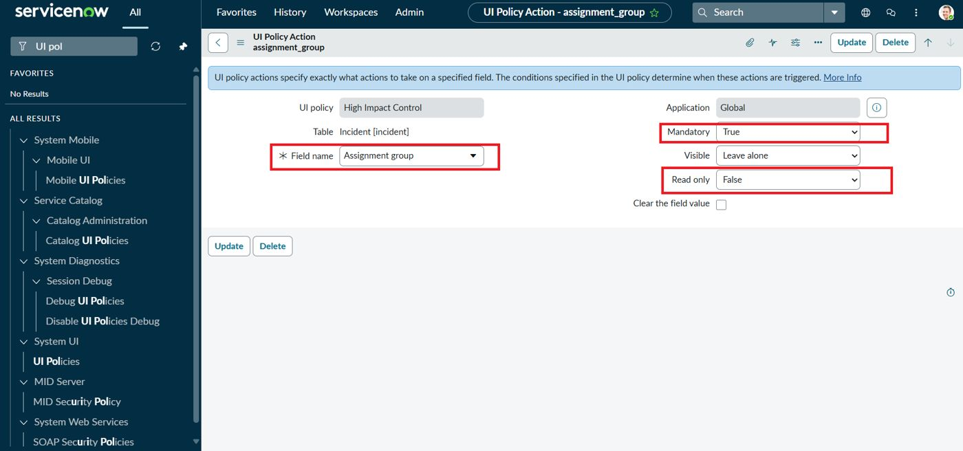
Figure 5: UI Policy Action: Assignment group mandatory
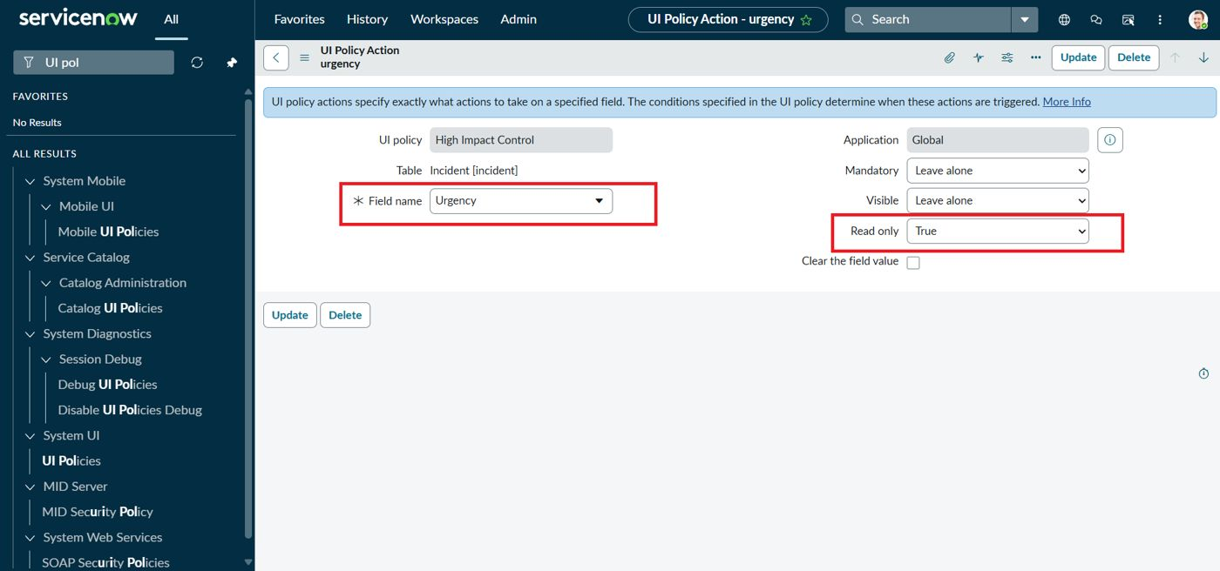
Figure 6: UI Policy Action: Urgency read-only
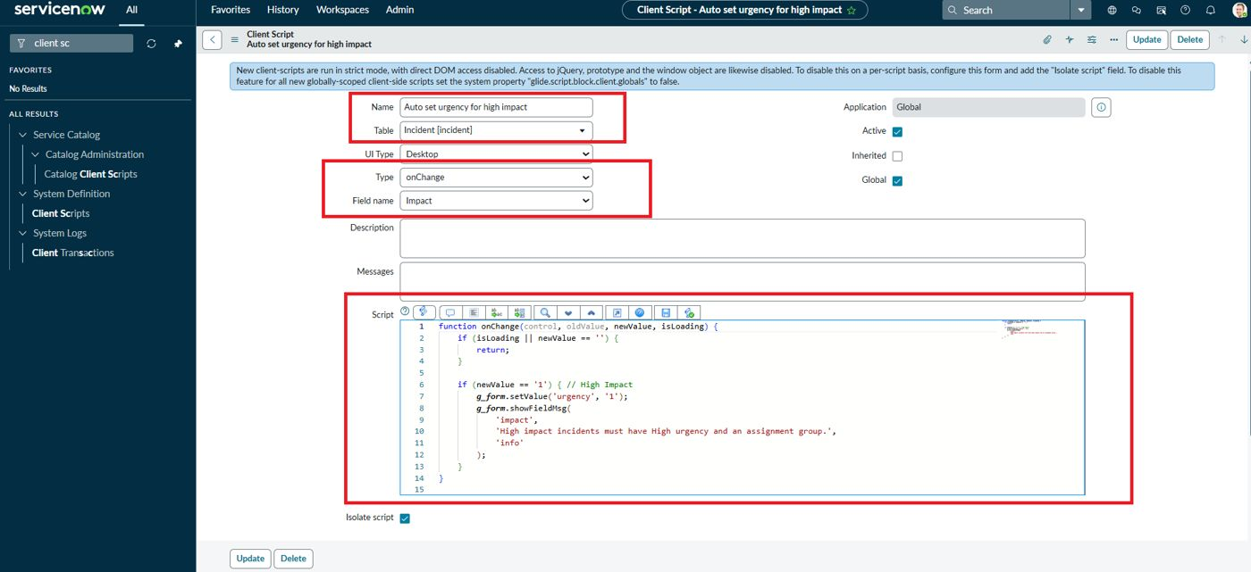
Figure 7: onChange Client Script (Auto set urgency for high impact)
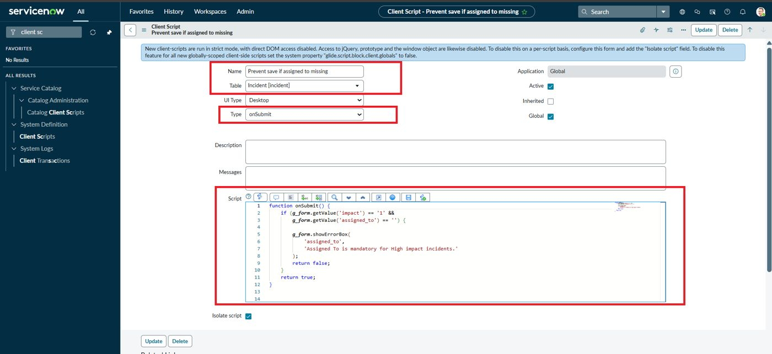
Figure 8: onSubmit Client Script (Prevent save if Assigned To missing)
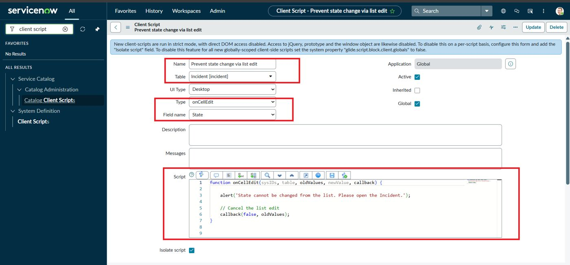
Figure 9: onCellEdit Client Script (Prevent state change via list edit)
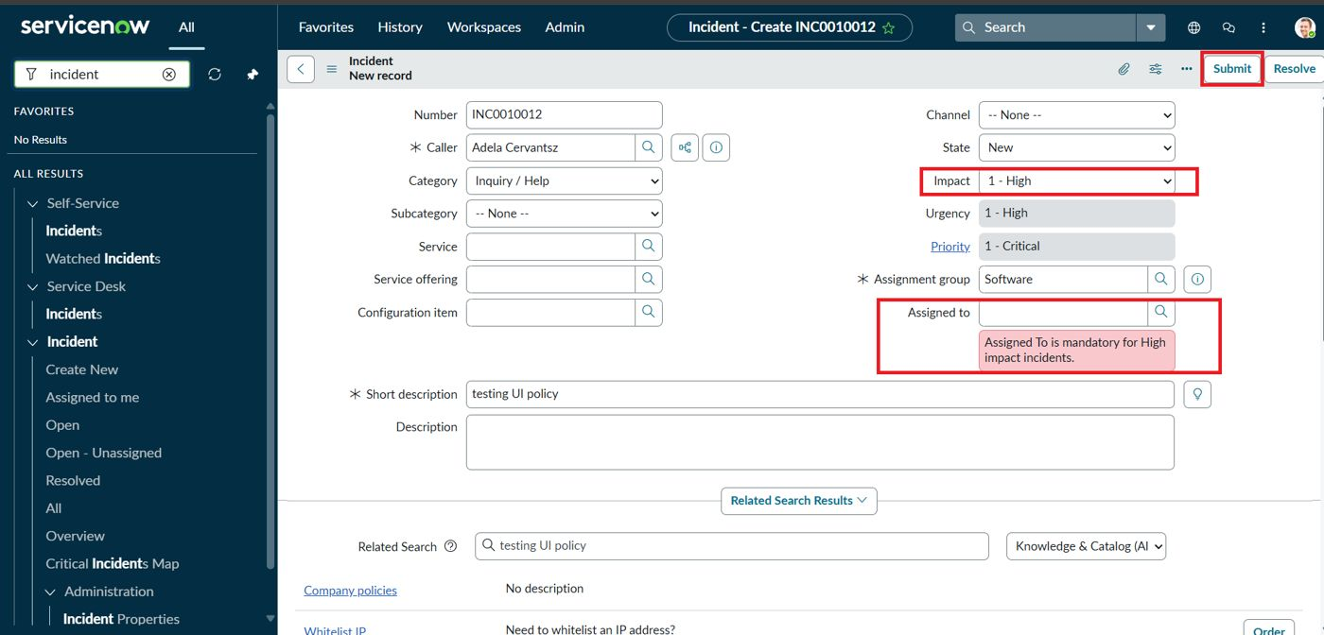
Figure 10: Save blocked for High impact without Assigned To
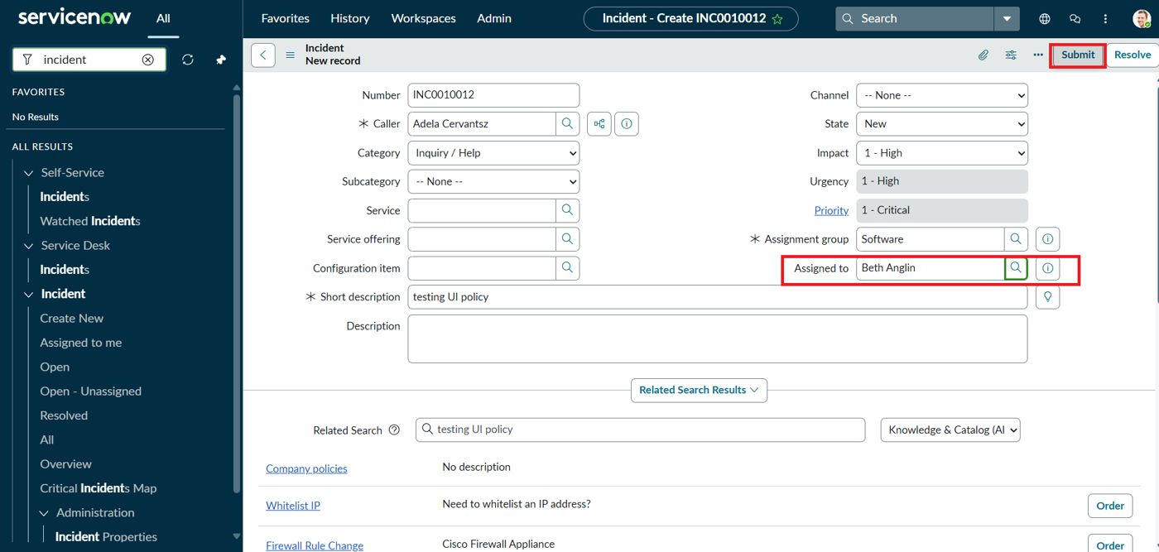
Figure 11: Successful save after selecting Assigned To
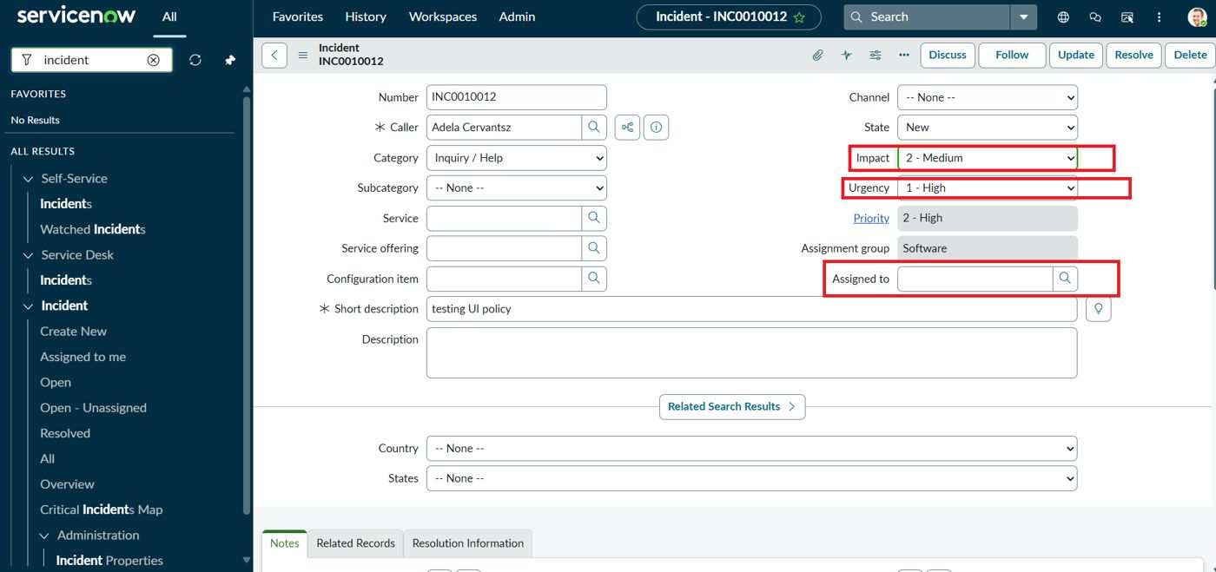
Figure 12: Reverse condition: Impact changed to Medium
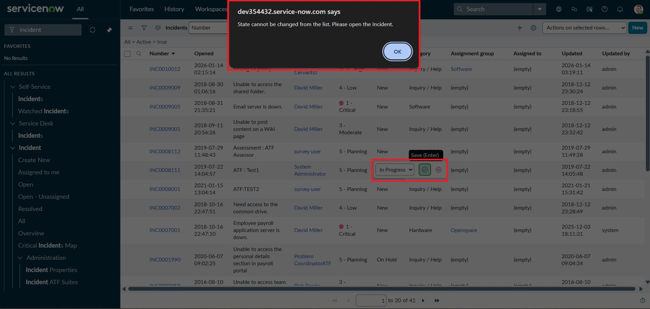
Figure 13: List edit of State blocked with an alert
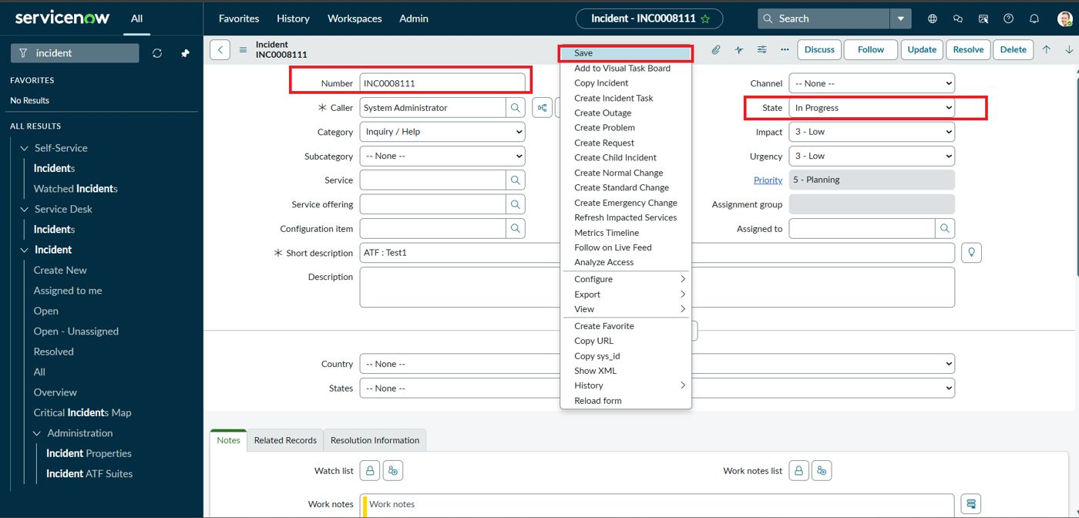
Figure 14: State updated from the Incident form

8. ADVANTAGES & DISADVANTAGES
Advantages
- Enforces data quality at entry, before the record is saved.
- Mostly declarative and low-code: one UI Policy plus three short scripts.
- Immediate on-screen feedback improves usability.
- Reversible behaviour (Reverse if false) avoids stuck fields.
- Lightweight: no server-side load for field behaviour.
- Closes the list-edit loophole for State changes.
Disadvantages
- Client-side rules do not apply to imports, integrations or API updates.
- Rules can be bypassed by users who disable scripts or use non-UI channels.
- onChange sets Urgency but does not reset it when Impact moves away from High.
- Hard-coded values ('1') depend on current choice-list values.
- onCellEdit blocks every State list edit, with no exceptions for authorised roles.

9. CONCLUSION
The project shows how UI Policies and Client Scripts work together to enforce dynamic field behaviour, automate updates and prevent incorrect data submission on Incident forms. Using onChange, onSubmit and onCellEdit scripts alongside UI Policy actions, fields such as Assigned To, Assignment group and Urgency respond appropriately to changes in Impact, keeping data clean and consistent. All nine test cases passed. The solution is lightweight, efficient and easy to implement, and it improves form usability and data integrity in ServiceNow.

10. FUTURE SCOPE
- Add server-side Business Rules or Data Policies as a second line of defence.
- Add an else branch to reset or unlock Urgency when Impact is no longer High.
- Allow role-based exceptions for list editing (for example, incident managers).
- Extend rules to Problem and Change tables.
- Replace hard-coded values with system properties.
- Add automated tests with ServiceNow ATF.

11. APPENDIX

Source Code
onChange Client Script: Auto set urgency for high impact (Table: Incident, Field: Impact)
function onChange(control, oldValue, newValue, isLoading) {
if (isLoading || newValue == '') {
return;
}

if (newValue == '1') { // High Impact
g_form.setValue('urgency', '1');
g_form.showFieldMsg(
'impact',
'High impact incidents must have High urgency and an assignment group.',
'info'
);
}
}
onSubmit Client Script: Prevent save if Assigned To missing (Table: Incident)
function onSubmit() {
if (g_form.getValue('impact') == '1' &&
g_form.getValue('assigned_to') == '') {

g_form.showErrorBox(
'assigned_to',
'Assigned To is mandatory for High impact incidents.'
);
return false;
}
return true;
}
onCellEdit Client Script: Prevent state change via list edit (Table: Incident, Field: State)
function onCellEdit(sysIDs, table, oldValues, newValue, callback) {

alert('State cannot be changed from the list. Please open the Incident.');

// Cancel the list edit
callback(false, oldValues);
}

Dataset Link
Not applicable. The project uses the standard ServiceNow Incident table; no external dataset was used.

GitHub & Project Demo Link
GitHub: [add your repository link here]
Project demo: [add your demo video link here]

